HTTP Methods

🧾 What Are HTTP Methods?
# Source: AI Source: Provided by: [Data Path: Persons Table -> ID Column: 1, Name_En Column: Motasem Essam] -> From: [ChatGPT] on [2/12/2026]
HTTP methods define the action you want to perform on a resource when making a request to a server.
👉 They tell the server: “What do you want to do?”

✅ Simple Definition:
# Source: AI Source: Provided by: [Data Path: Persons Table -> ID Column: 1, Name_En Column: Motasem Essam] -> From: [ChatGPT] on [2/12/2026]
An HTTP method is a verb used in an HTTP request to indicate the desired action (read, create, update, delete).

🧠 Real-Life Analogy:
# Source: AI Source: Provided by: [Data Path: Persons Table -> ID Column: 1, Name_En Column: Motasem Essam] -> From: [ChatGPT] on [2/12/2026]
Think of a library 📚:
● GET → “Give me this book”
● POST → “Add a new book”
● PUT → “Replace this book”
● DELETE → “Remove this book”

🔁 How HTTP Methods Work
# Source: AI Source: Provided by: [Data Path: Persons Table -> ID Column: 1, Name_En Column: Motasem Essam] -> From: [ChatGPT] on [2/12/2026]
- 👤 Client sends a request
- ⚙️ The request includes a method (GET, POST, etc.)
- 🧠 Server processes the request based on the method
- 📥 Server sends back a response

🔹 1. GET Method
# Source: AI Source: Provided by: [Data Path: Persons Table -> ID Column: 1, Name_En Column: Motasem Essam] -> From: [ChatGPT] on [2/12/2026]
👉 Used to retrieve data
● Does NOT change anything on the server
● Data is sent in the URL
💡 Example:
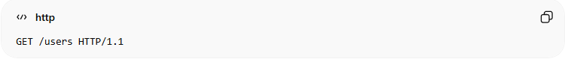
GET /users HTTP/1.1
👉 Example use:
- Get list of users
- Fetch product details

🔹 2. POST Method
# Source: AI Source: Provided by: [Data Path: Persons Table -> ID Column: 1, Name_En Column: Motasem Essam] -> From: [ChatGPT] on [2/12/2026]
👉 Used to send data to the server (create new data)
● Data is sent in the request body
● Often used in forms
💡 Example:
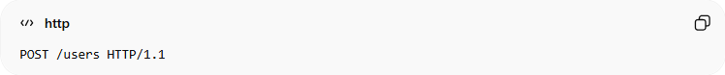
POST /users HTTP/1.1
👉 Example use:
- Register user
- Login
- Submit form

🔹 3. PUT Method
# Source: AI Source: Provided by: [Data Path: Persons Table -> ID Column: 1, Name_En Column: Motasem Essam] -> From: [ChatGPT] on [2/12/2026]
👉 Used to update or replace data
● Replaces the entire resource
💡 Example:
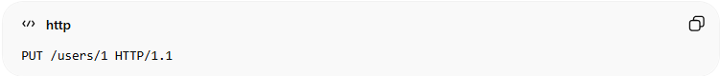
PUT /users/1 HTTP/1.1
👉 Example use:
- Update user profile

🔹 4. DELETE Method
# Source: AI Source: Provided by: [Data Path: Persons Table -> ID Column: 1, Name_En Column: Motasem Essam] -> From: [ChatGPT] on [2/12/2026]
👉 Used to delete data
💡 Example:
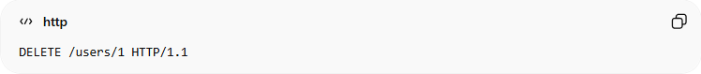
DELETE /users/1 HTTP/1.1
👉 Example use:
- Delete user
- Remove item from database

🔹 5. PATCH Method
# Source: AI Source: Provided by: [Data Path: Persons Table -> ID Column: 1, Name_En Column: Motasem Essam] -> From: [ChatGPT] on [2/12/2026]
👉 Used to partially update data
● Only updates specific fields
💡 Example:
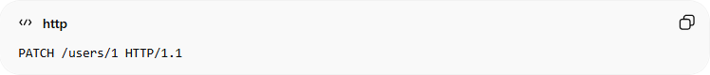
PATCH /users/1 HTTP/1.1
👉 Example use:
- Update only username
- Update email only

📊 Summary Table
# Source: AI Source: Provided by: [Data Path: Persons Table -> ID Column: 1, Name_En Column: Motasem Essam] -> From: [ChatGPT] on [2/12/2026]
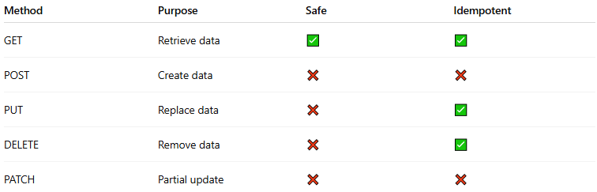
Method | Purpose | Safe | Idempotent
GET | Retrieve data | ✅ | ✅
POST | Create data | ❌ | ❌
PUT | Replace data | ❌ | ✅
DELETE | Remove data | ❌ | ✅
PATCH | Partial update | ❌ | ❌

🔗 Relation to Other Topics
# Source: AI Source: Provided by: [Data Path: Persons Table -> ID Column: 1, Name_En Column: Motasem Essam] -> From: [ChatGPT] on [2/12/2026]
● HTTP Methods → define the action
● HTTP Requests → carry the method
● APIs → use methods to perform operations
● Data Formats → sent with POST/PUT/PATCH

💻 Simple PHP Example
# Source: AI Source: Provided by: [Data Path: Persons Table -> ID Column: 1, Name_En Column: Motasem Essam] -> From: [ChatGPT] on [2/12/2026]
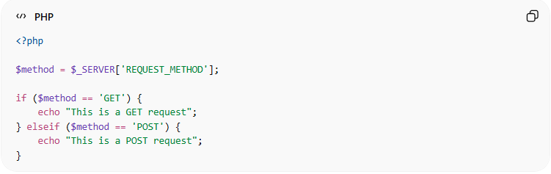
<?php

$method = $_SERVER['REQUEST_METHOD'];

if ($method == 'GET') {
echo "This is a GET request";
} elseif ($method == 'POST') {
echo "This is a POST request";
}
● PHP reads the request method
● Executes logic based on it

🎯 Key Idea
# Source: AI Source: Provided by: [Data Path: Persons Table -> ID Column: 1, Name_En Column: Motasem Essam] -> From: [ChatGPT] on [2/12/2026]
👉 GET = Read
👉 POST = Create
👉 PUT = Update (full)
👉 PATCH = Update (partial)
👉 DELETE = Remove

🎓 Final Mental Model
# Source: AI Source: Provided by: [Data Path: Persons Table -> ID Column: 1, Name_En Column: Motasem Essam] -> From: [ChatGPT] on [2/12/2026]
● Methods = actions on data
● Requests = carrying the method
● Server = executes the action

